Section J – 1503020
Pest Control

Attachment Number | Attachment Title
J-1503020-01 | Definitions and Acronyms
J-1503020-02 | New Pesticide Request and Planned Pesticide Use Sheet
J-1503020-03 | References and Technical Documents
J-1503020-04 | Service Level Standards
J-1503020-05 | Guidance for Contractor Work Plan
J-1503020-06 | Frequencies for Scheduled Work
J-1503020-07 | Nuisance Pest Requirements
J-1503020-08 | Public Health Pest Requirements
J-1503020-09 | Structure Damaging Pest Requirements
J-1503020-10 | Lawn, Turf and Ornamental Plant Pest Requirements
J-1503020-11 | Vegetation Management
J-1503020-12 | Vertebrate Pest Requirements
J-1503020-13 | Termite Control Specifications
J-1503020-14 | Historical Pest Control Service Orders
J-1503020-15 | Sample New Pest Management Record
J-1503020-16 | Historical Non-Recurring Work
J-1503020-17 | Station Maps, Main Station Admin, Ordnance, Normandy Road, Waterfront Inland and Pier Complex
J-1503020-18 | Building List of Facilities to receive Annual Termite Inspection

Attachment J-1503020-01
Definitions and Acronyms

Definition/Acronym | Description
Arthropod | The group of animals that includes insects, spiders, ticks, mites, silverfish, and related organisms.
Callback | A request for additional service or retreatment following the initial service that has not provided the control required. Callbacks shall be provided at no additional cost to the Government.
Certified Applicator/  Operator | An individual who has completed an EPA <<Note to Spec Writer: EPA not required OCONUS>> approved training program that includes written examinations in core and specific application categories and is certified by the state, or host nation in which they are applying pesticides to do so without supervision.
Contractor's Work Plan (CWP) for Pest Control | A Contractor developed document submitted as part of the Contractor proposal that describes how the requirements of this contract will be met. The plan establishes the strategies and methods for conducting a safe, effective, and environmentally sound pest management program.
Disease Vector | Any animal capable of transmitting the causative agent of a human disease. It is recognized that certain disease vectors are predominately nuisance or economic pests that as conditions change may require management or control as a disease vector.
Insect Growth Regulator (IGR) | Chemical substance that disrupts the action of insect hormones controlling molting, maturity from pupal stage to adult, and other growth functions for the purpose of insect control.
Integrated Pest Management Coordinator (IPMC) | The individual, fully trained in IPM principles and practice, designated by the installation commanding officer (CO) to coordinate and oversee all pest management activities at the installation.
Integrated Pest Management Plan (IPMP) | A required, written long-range, comprehensive planning and operational document that establishes the strategy and methods for conducting a safe, effective, and environmentally sound IPM program. IPM plans are a means of establishing and implementing installation pest management programs and function as the tool used to ensure compliance with applicable pest management laws and regulations.
Integrated Pest Management (IPM) | A planned program incorporating education, continuous surveillance, record keeping, and communication to prevent pests and disease vectors from causing unacceptable damage to operations, people, property, materiel, or the environment. IPM uses targeted, sustainable (effective, economical, environmentally sound) methods including habitat modification, biological, genetic, cultural, mechanical, physical, and regulatory controls; and when necessary, the judicious use of least hazardous pesticides.
Safety Data Sheet (SDS) | A document (Occupational Safety and Health Administration (OSHA) Form 174, or equivalent) that accompanies a pesticide product, providing the handler with chemical information on ingredients, handling instructions, potential hazards, and manufacturer address and emergency contact information.
Medically Important Pest | Any animal capable of transmitting the causative agent of a human disease serving as an intermediate or reservoir host of a pathogenic organism producing human discomfort or injury, including (but not limited to) mosquitoes, flies, other insects, ticks, mites, snails, and rodents.
Mission Impact Pest | Pests that may adversely affect the DoD mission or military operations; the health and well-being of people; or structures, material, or property.
Nuisance Pests | Arthropods, and other organisms, that do not cause economic damage or adversely affect human health, but which on occasion do cause annoyance.
Pest Management Performance Assessment Representative (PMPAR) | A DoD employee trained in pest management, who protects the government's interest through on-site performance assessment (PA) of commercial pest management contracts or other contracts that involve the use of pesticides.
Pest Management | The prevention and control of disease vectors and pests that may adversely affect the DoD mission or military operations; the health and well-being of people; or structures, material, or property.
Pest Management Consultant (PMC) | A professional, with a degree in a biological science, who has rigorous college-level entomology training, such as a NAVFAC civilian entomologist (applied biologist) or Bureau of Medicine and Surgery (BUMED) commissioned medical entomologist who has command program oversight responsibilities and provides guidance and information on the management of pest management programs for commands and installations.
Pesticide | Any substance or mixture of substances, including biological control agents, registered by EPA under FIFRA intended to destroy, repel, or mitigate pests. Includes insecticides, rodenticides, herbicides, fungicides, plant regulators, defoliants, desiccants, disinfectants, anti-fouling paints, and biocides (such as water treatment chemicals). NAVFAC pest management consultants do not approve disinfectants or biocides.
Pesticide Facility | The building and areas designated for handling, storing, and mixing of pesticides.
Pests | Any organism (except for micro-organisms that cause human or animal diseases) that adversely affects operations, preparedness, the well-being of humans or animals, real property, materiel, equipment or vegetation, or is otherwise undesirable.
Registered Pesticide | A pesticide registered by EPA for sale and use within the United States.
Road Mile/Kilometer | A unit of measure for measuring fogging application for adult mosquito control using a vehicle mounted Ultra Low Volume (ULV) aerosol generator traveling along a given route for a distance of 5,280 feet/1,000 meters.
Surveillance | Thorough inspections or surveys conducted before or after pest management treatments or on a regular basis to determine the presence and prevalence of pests or disease vectors.
Time Period to Maintain Control | A frequency specified on each Pest Group Sheet that is the minimum time the Contractor shall maintain control of pest(s) after reaching the specified level of control.
Time Period to Obtain Control | A frequency specified on each Pest Group Sheet that is the maximum time allotted for the Contractor to obtain control of pest(s) per the specified level of control.
Time Period to Respond | A frequency specified on each Pest Group Sheet that is the maximum time the Contractor is permitted to respond to a trouble call.>>

Attachment J-1503020-02

New Pesticide Request

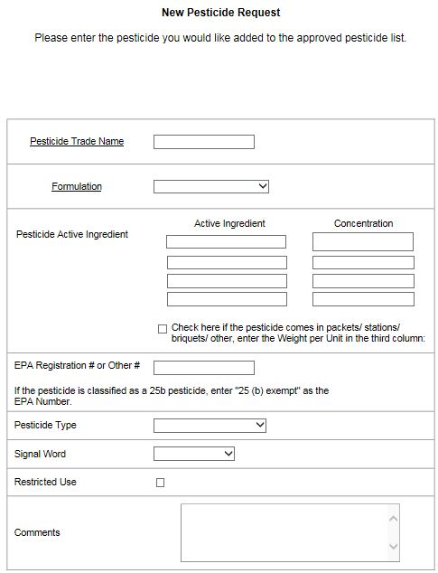
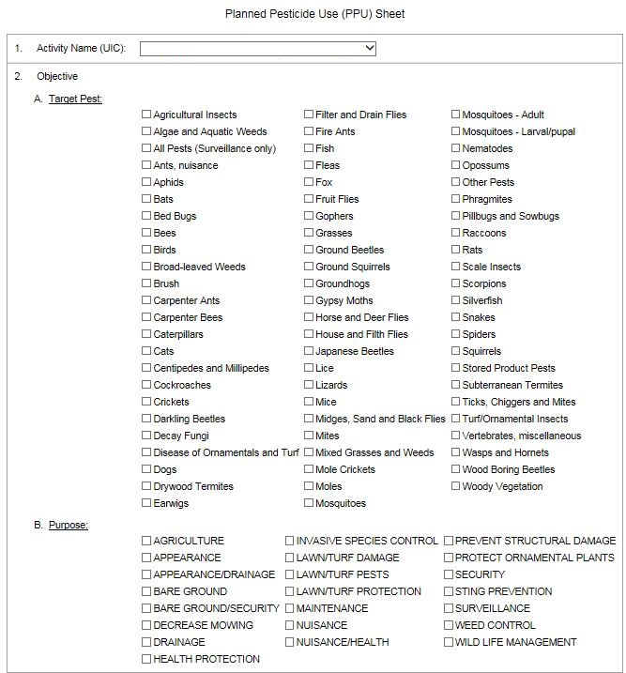
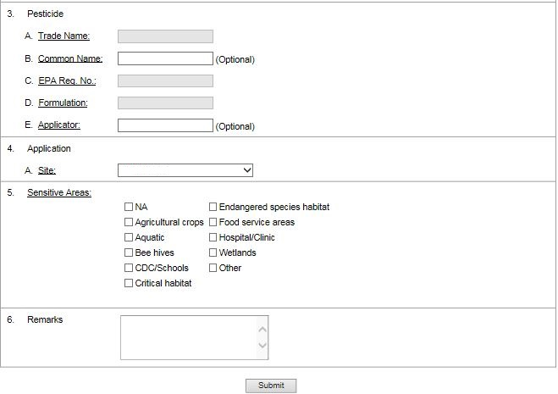

Attachment J-1503020-03
References and Technical Documents

The Contractor shall adhere to the applicable portions of the current edition of the following publications and directives in performing the services required under this contract:

- Department of Defense Directive 4150.07, Department of Defense Pest Management Program

- Executive Order 12088, Prevention, Control, and Abatement of Environmental Pollution at Federal Installations

- OPNAV Instruction 6250.4C, Navy Pest Management Programs

- OPNAVINST 5090.1, Environmental Readiness Program Manual, Chapter 24: Pesticide Compliance Ashore

- 42 U.S.C. 4321 et seq., National Environmental Policy Act (NEPA)

- 7 U.S.C. 136 et seq., Federal Insecticide, Fungicide and Rodenticide Act (FIFRA) as amended

- 16 U.S.C. 1531 et seq., Endangered Species Act

- 42 U.S.C. 6901 et seq., Resource Conservation and Recovery Act (RCRA)

Attachment J-1503020-04
Service Level Standards

The table below applies to all facilities/spaces listed in the Frequencies for Scheduled Work provided in J-1503010-06.The Contractor shall price work requirements as detailed per COL Base or Additional Measures Level in the corresponding ELIN listed in J-0200000-09.
COL3 | Mission Impact Pests¹ – Routine surveillance and treatment is conducted in accordance with the IPMP.  Structure Damaging and Disease Vector or Health Pests – Routine surveillance and treatment is conducted in accordance with the IPMP.  Lawn Turf and Ornamental Plant Pests – No surveillance in any grounds areas and treatment in prestige areas is conducted in response to customer complaints only. No treatment in improved grounds areas.  Nuisance Pests² – Routine surveillance and treatment conducted in accordance with the IPMP is limited to Child and Youth Program facilities, food handling and dining facilities, and administrative areas. No surveillance in operational areas. Treatment of operational areas is conducted in response to customer complaints only.  Vegetation control – Routine maintenance performed only for fencelines, fire breaks, and roadway clearances. Vegetation control as necessary to prevent damage to paved surfaces shall be ordered as IDIQ work.

COL4 | Mission Impact Pests¹ - Routine surveillance and treatment is conducted in accordance with the IPMP.  Structure Damaging and Disease Vector or Health Pests – Routine surveillance and treatment is conducted in accordance with the IPMP.  Lawn Turf and Ornamental Plant Pests – No surveillance or treatment in prestige and improved grounds areas.  Nuisance Pests² - Routine surveillance and treatment conducted in accordance with the IPMP is limited to Child and Youth Program facilities, food handling and dining facilities only. No routine surveillance in operational and administrative areas. Treatment of operational and administrative areas is conducted in response to customer complaints only.  Vegetation control – Routine maintenance performed only for fencelines, fire breaks, and roadway clearances. Vegetation control as necessary to prevent damage to paved surfaces shall be ordered as IDIQ work.
Note 1: Mission impact pests are indicated on the Frequencies for Scheduled Work provided in J-1503010-06.

Note 2: All Vertebrate pests are treated as Nuisance Pests unless otherwise specified.

ATTACHMENT J-1503020-05
GUIDANCE FOR CONTRACTOR’S WORK PLAN (CWP)

The CWP shall adhere to applicable publications and directives contained in J-1503020-03 (References and Technical Documents. The CWP will require approval by the Contracting Officer (KO). The CWP shall establish the strategy and methods for conducting a safe, effective, and environmentally sound pest management program in compliance with these specifications. Prospective contractors may review the installation’s historical records of pest activity and abatement actions, survey facilities and grounds, and consult with the Installation IPMC in development of a plan. The CWP shall address continuous monitoring, pest response and removal procedures, record keeping, warranties, education and communication to installation personnel to prevent pests and disease vectors, bird control on applicable airfields and in hangars, etc. The IPM approach should use targeted (i.e., effective, environmentally sound) methods including habitat/facility modification, biological/genetic/cultural control, mechanical/physical control, and where necessary, the judicious use of least hazardous pesticides. The CWP shall include labels, SDS sheets, and Planned Pesticide Use Sheets and comply with all applicable local, state, and Federal regulations, and the IPMP.

Attachment J-1503020-06

Frequencies for Scheduled Work

The following buildings will be surveyed on the specified frequencies and treated as indicated on the pest group sheets:

Customer | Facility No. | Area (SF) | Facility Description | Mission Impact Pests | Frequency
E | C-29 | 1,500 | Snack-Bar (Food Prep Area / Kitchen ) | Roaches and Rodents | Bi-Weekly
 | C-4 | 6,500 | Wind Jammer Club (Bar, Food Prep Area/Kitchen, Storage) | Roaches and Rodents | Bi-Weekly
 | C-60 | 8,642 | Child Day Care Center (Food Prep Area/Kitchen,  Storage | Roaches and Rodents | Bi-Weekly
 | C-62 | 9,287 | Family Center (Food Prep Area/Kitchen) | Roaches and Rodents | Bi-Weekly
 | R-23 | 6,045 | Bay Breeze Club (Fitness Center) | Roaches and Rodents | Bi-Weekly
 | C-3 | 12,360 | Medical and Dental Complex (Hospital) | Roaches and Rodents | Monthly
 | C-22 | 500 | Fire Station (Food Prep Area/Kitchen) | Roaches and Rodents | Monthly
 | C-10 | 15,175 | Barracks with Kitchenettes | Roaches and Rodents | Monthly
 | C-11 | 15,175 | Barracks with Kitchenettes | Roaches and Rodents | Monthly
 | C-12 | 15,175 | Barracks with Kitchenettes | Roaches and Rodents | Monthly
 | C-13 | 15,175 | Barracks with Kitchenettes | Roaches and Rodents | Monthly
 | C-60 | 261,360 | Child Day Care Center, Tick Surveillance/ Control, 6 Acres | Ticks | Monthly
 | C-66 | 3,240 | Military Working Dog Complex (Kennel) | All Pests | Monthly
 | R-1 | 500 | Fire Station (Food Prep Area/Kitchen | Roaches and Rodents | Monthly
 | Station Wide 58 Buildings | See Attachment J-1503020-13 | Termite Inspections for fifty-eight buildings. Identified on Attachment J-1503020-13. | Termites | Annual average five inspections per month x 12 months. ELIN to reflect as monthly, for billing purposes.
 | S-60 | 9,000 | Waterfront Electrical Sub-Station - Weed Control | Weed and brush Control | As Required to Maintain
 | S-40 | 400 | Electrical Sub-Station-C-29- Weed Control | Weed and brush Control | As Required to Maintain
 | S-71 | 8,500 | Main Station Electrical Sub-Station – Weed Control | Weed and brush Control | As Required to Maintain
 | C-60 | 700 | Electrical Sub-Station – Weed Control | Weed and brush Control | As Required to Maintain
 | C-62 | 650 | Electrical Sub-Station – Weed Control | Weed and brush Control | As Required to Maintain
 | S-91 | 500 | Electrical Sub-Station – Weed Control | Weed and brush Control | As Required to Maintain
 | C-8 | 200 | Abandoned Electrical Unit | Weed and Brush Control | As Required to Maintain
 | C-4 | 500 | Station near C-4 | Weed and Brush Control | As Required to Maintain
 | Stark Rd. Housing | 1500 | Kiser Court Sub-Station | Weed and Brush Control | As Required to Maintain
 | Army Area | 150 | Truck Holding Yard Generator | Weed and Brush Control | As Required to Maintain
 | Army Area | 250 | Truck Holding Yard Generator | Weed and Brush Control | As Required to Maintain
 | F-8 | 250 | Generator across from F-8 | Weed and Brush Control | As Required to Maintain
 | R-10 | 600 | Waterfront Electrical Sub-Station | Weed and Brush Control | As Required to Maintain
 | R-15 | 300 | Station west of R-15 | Weed and Brush Control | As Required to Maintain
 | Garret Hill | 1400 | Antenna Building Lot | Weed and Brush Control | As Required to Maintain
 | Dunnage Yard | 600 | Waterfront Fire Department Pump Box | Weed and Brush Control | As Required to Maintain
 | R-32 | 400 | Generator near southwest corner of building | Weed and Brush Control | As Required to Maintain

Attachment J-1503020-07
Nuisance Pest Requirements

Pest Group Number |  | Pest Group Name |  |  | General Requirements
001 |  | Ant Control |  |  | Prevent and control ants in and around buildings and structures.
002 |  | Arthropod Control in Food Handling Establishments |  |  | Prevent/control all arthropod pests in food handling establishments. Arthropod pests include, but are not limited to, cockroaches, ants (excludes fire ants which are covered under a separate pest group), silverfish, centipedes, ground beetles, fleas, spiders, stored product pests, etc.
003 |  | Cockroach Control |  |  | Prevent and control all cockroaches.
004 |  | Flea Control in and Around Buildings and Structures |  |  | Control flea infestations in and around buildings and structures.
005 |  | Miscellaneous Arthropod Pest Control |  |  | Prevent and control nuisance arthropod pests in and around buildings and structures. Includes but is not limited to spiders, silverfish, scorpions, crickets, centipedes, millipedes, box elder bugs, parasitic or biting mites, beetles, etc. (Excludes ants, cockroaches, filth flies, and bees/wasps/hornets covered in separate sections.)
006 |  | Stored Product Pest Control (Arthropods) |  |  | Control and prevent stored product pests at designated sites.
Performance Standards
Pest Group Number | Pest Group Name |  | Time Period to Respond¹ | Time Period to Obtain Control² |  | Time Period to Maintain Control | Level of Control³ | Notes  See Below
001 | Ant Control |  | 24 hrs. | 7 days |  | 28 days | 100% control | 1, 2, 3, 4
002 | Arthropod Control in Food Handling Establishments |  | 24 hrs. | 7 days |  | 28 days | Retreatment required if:  -Cockroaches: 4 or more adults or nymphs or 1 egg capsule per room  -Ants: 4 or more  -Centipedes/Spiders: 1 or more  -Other Arthropods: 3 or more | 1, 2, 3, 4
003 | Cockroach Control |  | 24 hrs. | 7 days |  | 28 days | Retreatment required if:  4 or more adults or nymphs or 1 egg capsule per room | 1, 2, 3, 4
004 | Flea Control |  | 24 hrs. | 7 days |  | 28 days | 100% control | 1, 4, 5
005 | Miscellaneous Arthropod Pest Control |  | 24 hrs. | 7 days |  | 28 days | Sensitive areas:100% control  Mites: 100% control  Retreatment required if:  - Food Handling: 3 or more arthropods/room/survey  - Offices/Admin: 3 or more arthropods/room/survey  - Industrial Areas: 5 or more arthropods/room/survey  - Outdoors: 5 or more arthropods in a 100 square foot area | 4
006 | Stored Product Pest Control |  | 24 hrs. | 24 hrs. |  | 28 days (residual)  7 days (ULV) | Sighting of any exposed, living, stored product pest(s) after 72 hours shall require retreatment | 1, 4, 5, 6
Superscript:
- After notification.
- After first control action.
- Based on performance assessment (i.e., surveys, customer complaints).

Notes:
- Regularly scheduled, periodic pesticide applications are not approved for DoD property.
- Liquid, dust, or aerosol pesticide formulations shall not be applied indoors when food is exposed or spaces are occupied.
- Treatment of areas outside or adjacent areas to the designated area does not constitute an added service call or charge.
- Report conditions conducive to pest infestation to the COR and PAR within one working day following survey.
- Coordinate with residents/building personnel on specific treatment and re-entry times.
- The ULV machine shall be calibrated for generating proper droplet sizes and range before starting any work under this contract and thereafter every 90 days or every 50 hours of use, whichever comes first. Maintain a log of ULV machine hour use.

Attachment J-1503020-08
Public Health Pest Requirements

Pest Group Number | Pest Group Name |  |  | General Requirements
007 | Aerial Spray Support and Operations |  |  | Provide ground support services for aerial spray operations.
008 | Adult Mosquito Control |  |  | Application of a mosquito adulticide (ULV Formulation) at designated sites when directed by COR.
009 | Adult Mosquito Control - Residual |  |  | Application of a mosquito adulticide (residual spray) at designated sites when directed by COR.
010 | Adult Mosquito Surveillance |  |  | Survey for adult mosquitoes using light trap(s) and deliver catches to Installation Preventive Medicine.
011 | Bed Bugs |  |  | Control all bedbugs.
012 | Bee, Wasp, Hornet, and Stinging Arthropod Control |  |  | Control stinging arthropod infestations in and around buildings, structures, and areas. Pests include, but are not limited to, bees, wasps, hornets, cicada killers, yellow jackets, and solitary wasps (mud daubers, umbrella wasps).
013 | Childcare Facilities/Sensitive Areas Pest Control (Includes: Schools, Hospital, Veterinary Clinic and Kennels, Child Development Center, Youth Activities Center) |  |  | Control all nuisance arthropod pests (including, but not limited to), cockroaches, ants, silverfish, spiders, crickets, flies, centipedes, box elder bugs, mites, bees, wasps, other venomous arthropods, AND all species of rodents in areas where children frequent including child care, schools, day care, nurseries and other locations as designated.
014 | Filth Fly Control |  |  | Prevent and control filth flies including house flies, flesh flies, bottle flies, blow flies, fruit flies, and other related insects that breed or are attracted to garbage and trash in area designated by the COR. Identify source, if applicable.
015 | Larval and Pupal Mosquito Control |  |  | Control of larval and pupal mosquitoes in designated area(s) when directed by COR (medical personnel determine when to control).
016 | Larval Mosquito Surveillance |  |  | Survey designated mosquito breeding sites for immature mosquitoes (eggs, larvae, and pupae) and deliver catches to Installation Preventive Medicine.
017 | Tick Survey and Control Outdoors |  |  | Survey for and control of ticks outdoors.
018 | Fire Ant Control |  |  | Prevent and control fire ants indoors and outdoors. Sites include all improved, operational areas and other designated sites.
Performance Standard
Pest Group Number | Pest Group Name | Time Period to Respond | Time Period to Obtain Control |  | Time Period to Maintain Control | Level of Control | Notes See Below
007 | Aerial Spray Support and Operations | 24 hrs. | N/A |  | N/A | All services rendered within time period requested | 8
011 | Bed Bug Control | 24 hrs. | 7 days |  | 60 days | 100% control | 1, 2, 3, 4, 6
012 | Bee, Wasp, Hornet, and Stinging Arthropod Control | 4 hrs. | 24 hrs. (stinging hazard)  2 days (nest removal) |  | 28 days | 100% control | 2, 4
013 | Childcare Facilities/Sensitive Areas Pest Control | 24 hrs; Same day (venomous) | Varies² |  | 28 days | 100% control | 1, 2, 3, 4, 5, 6
014 | Filth Fly Control | 24 hrs. | 2 days |  | 28 days | Indoors: 100% control  Retreatment required if:  -Outdoors/Dumpsters: 10 or more adults or immatures  -Outdoors: 5 or more adults or immatures | 1, 2, 3, 4
017 | Tick Survey and Control Outdoors | 24 hrs. | 3 days |  | 28 days | Retreatment required if:  Improved areas: 3 or more ticks seen or 3 customer complaints  Semi-Improved Area or Unimproved Area: 10 or more ticks by survey, 3 customer complaints, or 3 ticks seen | 6

NOTES:
1 - Regularly scheduled, periodic pesticide applications are not approved for DoD property.
2 - Liquid, dust, or aerosol pesticide formulations shall not be applied indoors when food is exposed or spaces are occupied.
3 - Treatment of areas outside or adjacent areas to the designated area does not constitute an added service call or charge.
4 – Report conditions conducive to pest infestation to the KO and Integrated Pest Management Coordinator within one working day following survey.
5 - Pesticide applications shall not be made during hours of operations or when children are present at schools, child development centers, and youth activity centers.
6 - Coordinate with residents/building personnel on specific treatment and re-entry times.
7 - The ULV machine shall be calibrated for generating proper droplet sizes and range before starting any work under this contract and thereafter every 90 days or every 50 hours of use, whichever comes first. Maintain a log of ULV machine hour use.
8 - Aerial applications of pesticides require validation and approval by a pest management consultant.
9 - The adulticide is applied at maximum label rate for the adulticide used.
10 - The KO shall designate areas where mosquito larva should be controlled on a map supplied by the government. The areas may be intermittent water (developed from surveys for larval breeding sites), or permanent water sites

Attachment J-1503020-09
Structure Damaging Pest Requirements

Pest Group Number |  |  |  | Pest Group Name |  |  |  |  |  |  |  |  | General Requirements
019 |  |  |  | Other Wood Destroying Organisms (Non-Termite) Control |  |  |  |  |  |  |  |  | Prevent, manage, and control non-termite wood destroying organisms including, but not limited to powder post beetles (Lyctids and Bostrichids), Anobiids (furniture and deathwatch beetles), old house borer, carpenter ants, and carpenter bees.
020 |  |  |  | Survey for Termite and Wood Destroying Organisms |  |  |  |  |  |  |  |  | Survey for all termite species and other wood destroying organisms including fungal rots, carpenter ants, and wood boring beetles.
Performance Standard
Pest Group Number |  | Pest Group Name |  |  |  |  | Time Period to Respond¹ |  |  |  |  | Time Period to Obtain Control² |  |  |  | Time Period to Maintain Control |  |  |  | Level of Control³ |  | Notes  See Below
019 |  | Other Wood Destroying Organisms (Non-Termite) Control |  |  |  |  | 24 hrs. |  |  |  |  | 7 days |  |  |  | 28 days |  |  |  | 100% control |  | 1, 2, 5
020 |  | Survey for Termite and Wood Destroying Organisms |  |  |  |  | Same day (swarming)  5 days (not swarming) |  |  |  |  | N/A |  |  |  | 2 Working Days (submit report) |  |  |  | N/A |  | 2, 3, 4  See Pest Group 019: Termite and Wood Decay Inspection Below
Superscript:
- After notification.
- After first control action.
- Based on performance assessment (i.e., surveys, customer complaints).
Notes:
- Liquid, dust, or aerosol pesticide formulations shall not be applied indoors when food is exposed or spaces are occupied.
- Report conditions conducive to pest infestation to the COR within one working day following survey.
- Use the Termite and Wood Decay Inspection - DD Form 1070 and submit report to the KO and COR within two working days following survey.
- Follow Termite Control Specifications (below) for termite management.
- If the infestation is a beetle species that will not reinfest seasoned dead wood, treatment shall not be performed. Provide a report to the KO and COR within two working days following survey detailing the species of beetle and the fact that it will not reinfest seasoned dead wood. This should refer to parasitic or biting mites only, e.g. bird mites, chiggers.

DD FORM 1070
TERMITE AND WOOD DECAY INSPECTION  (DD Form 1070) (Use with Pest Group Sheet 019) |  |  |  |  |  |  |  |  |  |  |  |  |  |  |  |  |  |  |  |  | DATE INSPECTED |  | BUILDING NUMBER
INSTALLATION |  |  |  |  |  |  |  |  |  |  | TYPE BUILDING |  |  |  |  |  | INSPECTOR
 |  |  |  |  |  |  |  |  |  |  | PERM TEMP

I. FAVORABLE TERMITE AND FUNGI INFESTATION CONDITIONS
 | WOOD IN CONTACT WITH SOIL |  |  |  |  |  |  |  |  |  |  |  |  |  |  |  | POOR VENTII ATION UNDER BUILDING
 | FORM BOARDS LEFT IN CONCRETE |  |  |  |  |  |  |  |  |  |  |  |  |  |  |  | WATER COLLECTIONS UNDER BUILDING
 | WOOD MEMBERS SET IN CONCRETE FLOOR |  |  |  |  |  |  |  |  |  |  |  |  |  |  |  | VINES AND SHRUBS AGAINST BUILDING
 | WOOD STEPS IN CONTACT WITH SOIL |  |  |  |  |  |  |  |  |  |  |  |  |  |  |  | LEAKY PLUMBING IN PUTTING
 | WOOD STEPS WITHOUT SHIELDS |  |  |  |  |  |  |  |  |  |  |  |  |  |  |  | WOOD SCRAP PILED TINDER BUILDING
 | WOOD SIDING IN CONTAI.T WITH SOIL |  |  |  |  |  |  |  |  |  |  |  |  |  |  |  | LOOSE WIRE IN CONTACT WHH SOIL
 | PIPES IN CONTACT WITH SOIL AND WOOD |  |  |  |  |  |  |  |  |  |  |  |  |  | OTHER (Specify)
 | NO SHIELDS ON FOUNDATION
 | FAULTY TERMITE SHIELD

II. LOCATION OF INFESTATIONS
 | FOUNDATION TIMBERS |  |  |  |  |  |  |  |  |  |  |  |  |  |  |  | BASEBOARDS
 | WOOD PILLARS |  |  |  |  |  |  |  |  |  |  |  |  |  |  |  | DOOR FRAMES
 | SILLS |  |  |  |  |  |  |  |  |  |  |  |  |  |  |  | WINDOW FRAMES
 | CROSS BEAMS |  |  |  |  |  |  |  |  |  |  |  |  |  |  |  | STEPS
 | FURNITURE |  |  |  |  |  |  |  |  |  |  |  |  |  |  |  | ROOF
 | FLOOR JOIST |  |  |  |  |  |  |  |  |  |  |  |  |  | OTHER (Specify)
 | FLOOR
 | STUDS
III. TYPE OF TERMITE |  |  |  |  |  |  |  | IV. TYPE OF FUNGI |  |  |  |  |  |  |  |  | V. DAMAGE
 | SUBTER-  RANEAN |  |  |  | NONSUBTER  RANEAN |  |  |  | WOOD DECAY |  |  |  |  | W000  STAINING |  |  |  | STRUCTURAL  WEAKENING |  |  | SUPERFICIAL |  | ESTIMATED COST

VI. REPAIR AND TREATMENT
TYPE |  |  |  |  |  |  |  |  |  | RECM | ACCOMP |  |  |  | TYPE |  |  |  |  |  |  |  | RECM | ACCOMP
REMOVAL OF WOOD FROM SOIL CONTACT |  |  |  |  |  |  |  |  |  |  |  |  |  |  | REPAIR OF TERMITE SHIELDS
SEALING CRACKS IN CONCRETE |  |  |  |  |  |  |  |  |  |  |  |  |  |  | REMOVAL OF CONCRETE FORMS
POINTING UP POOR MORTAR |  |  |  |  |  |  |  |  |  |  |  |  |  |  | REMOVAL OF VINES AND SHRUBS
LOWERING GRADE LEVEL |  |  |  |  |  |  |  |  |  |  |  |  |  |  | REMOVAL OF WOOD TRASH
CAPPING CONCRETE FOUNDATION |  |  |  |  |  |  |  |  |  |  |  |  |  |  | OTHER (Specify)
IMPROVING DRAINAGE UNDER BUILDING
IMPROVING VENTILATION UNDER BUILDING

VII. CHEMICAL CONTROL
APPLICATION OF POISON DUST TO SHELTER TUBES  YES NO |  |  |  |  |  |  |  |  |  |  |  |  |  |  | CHEMICAL USED
SOIL POISON  YES NO |  |  |  |  |  |  |  |  |  |  |  |  |  |  | TRENCH DEPTH |  |  | LINEAR FEET |  |  | CHEMICAL USED
REPLACEMENT OF DAMAGED WOOD  YES NO |  |  |  |  | NO. OF M BD FELT REPLACED |  |  |  |  | UNTREATED |  |  |  |  | DIPPED |  |  | SOAKED |  |  | SPRAYED |  | PRESSURE TREATED
DRILLING AND FLOODING TREATMENTS YES NO |  |  |  |  |  |  |  |  |  |  |  |  |  |  | CHEMICAL USED
WOOD INJECTION FOR DRY WOOD TERMITE YES NO |  |  |  |  |  |  |  |  |  |  |  |  |  |  | CHEMICAL USED

VIII. COST
LABOR |  |  |  |  |  | MATERIAL |  |  |  |  |  |  |  |  | OTHER |  |  |  |  |  | TOTAL

IX. TREATMENT EFFECTIVENESS
DATE |  |  | REMARKS |  |  |  |  |  |  |  |  |  |  |  |  |  |  |  |  |  | INSPECTOR
DATE |  |  | REMARKS |  |  |  |  |  |  |  |  |  |  |  |  |  |  |  |  |  | INSPECTOR
DATE |  |  | REMARKS |  |  |  |  |  |  |  |  |  |  |  |  |  |  |  |  |  | INSPECTOR
DATE |  |  | TITLE OF INDIVIDUAL AFFECTING REPAIR AND TREATMENT |  |  |  |  |  |  |  |  |  |  |  | SIGNATURE

Attachment J-1503020-10
Lawn Turf and Ornamental Plant Pest Requirements

Pest Group Number |  | Pest Group Name |  |  |  | General Requirements
022 |  | Turf and Ornamental Pest Control |  |  |  | Control arthropod pests in turf and on ornamental plantings.
Performance Standard
Pest Group Number | Pest Group Name |  | Time Period to Respond¹ | Time Period to Obtain Control² | Time Period to Maintain Control |  | Level of Control³ | Notes  See Below
022 | Turf and Ornamental Pest Control |  | 3 days | 7 days | 28 days |  | No turf pests after 1 week  Retreatment required if:  - 3 or more leaf feeding arthropods on 20 leaves surveyed, OR  - 3 or more bagworms on 20 evergreen branches surveyed, OR  - 3 or more scale insects on 5 tree branches surveyed, OR  - 3 or more scale insects on 6 ornamental branches surveyed, OR  - Defoliation of 10% or more of the plant compared to a previous observed status, OR  - General, noticeable physical decline of a plant that is caused by a pest, disease, or other damaging biotic agent. | 1, 3, 4
Superscript:
- After notification.
- After first control action.
- Based on performance assessment (i.e., surveys, customer complaints).

Notes:
- Report conditions conducive to pest infestation to the COR within one working day following survey.
- The Contractor may provide irrigation if required at no additional cost. Water for irrigation may be made available for the Contractor's use at fire hydrants located throughout the activity area; however, the COR should be contacted prior to their use.
- Post/Notify as required by applicable state/local regulations.
- Misapplication to target areas, or drift, runoff or other off-target effects that kill or damage any vegetation shall result in the Contractor replacing that vegetation at no charge to the Government.

Attachment J-1503020-11
Vegetation Management Requirements

 | Pest Group Number |  | Pest Group Name |  |  | General Requirements
 | 023 |  | Aquatic Plant Control |  |  | Control aquatic weeds in ditches, ponds, lakes, and other aquatic sites.
 | 024 |  | Industrial, Sidewalk, Substation, Vault, and Right-Of-Way Weed Control |  |  | Provide bare ground weed control in cracks in sidewalks and paved surfaces, at fence line locations, in transformer vaults, around fire hydrants, and other designated locations.
 | 025 |  | Turf and Ornamental Bed Weed Control |  |  | Control weeds in turf areas and in ornamental plant beds.
 | Performance Standard
 | Pest Group Number | Pest Group Name |  | Time Period to Respond¹ | Time Period to Obtain Control² |  | Time Period to Maintain Control | Level of Control³ | Notes  See Below
 | 023 | Aquatic Plant Control |  | 7 days | 21 days |  | 60 days | 100% control | 2, 3, 4
 | 024 | Industrial, All Sidewalks, curbs Substations, Vault, and Right-Of-Way Weed Control, asphalt, fence line |  | 3 days | 7 days |  | Consult PMC | Consult PMC | 3
 | 025 | Turf and Ornamental Bed Weed Control |  | 3 days | 7 days |  | Season long | More than 4 weed plants per ornamental bed or 1600 ft² of turf are grounds for retreatment of that area at the Contractor’s expense. | 1, 2, 3
Superscript:
- After notification.
- After first control action.
- Based on performance assessment (i.e., surveys, customer complaints).

Notes:
- Report conditions conducive to pest infestation to the COR within one working day following survey.
- Post/Notify as required by applicable state/local regulations.
- Misapplication to target areas, or drift, runoff or other off-target effects that kill or damage any vegetation shall result in the Contractor replacing that vegetation at no charge to the Government.
- Permits may be required to perform this work (i.e., NPDES permit, FWS permit). The contractor shall obtain all permits and provide a copy to the KO and COR prior to commencing control.

Attachment J-1503020-12
Vertebrate Pest Requirements

 | Pest Group Number | Pest Group Name |  |  | General Requirements
 | 026 | Bat Control in Buildings |  |  | Control/exclude bats from buildings in accordance with state regulations.
 | 027 | Commensal Rodents In and Around Buildings and Structures |  |  | Prevent and control rodents indoors or within 75 linear feet of the exterior walls of designated buildings and structures. Rodent pests include, but are not limited to Norway rats, roof rats, house mice, field mice, groundhogs (woodchucks) and other marmots. Service requires removal of dead animals.
 | 028 | Pest Bird Control (including Bird Aircraft Strike Hazard reduction activities) |  |  | (1) Prevent and control birds inside and outside buildings/structures, and (2) Prevent and control birds roosting/nesting on aircraft operation areas.
 | 029 | Pest Vertebrate Control |  |  | Control pest vertebrate animals including, but not limited to, feral dogs and cats, squirrels, skunks, snakes, opossums, raccoons, and mongoose, deer. Roadkill. Trapping/baiting and removal. Comply with local laws and regulations.
 | Performance Standard
 | Pest Group Number | Pest Group Name | Time Period to Respond¹ | Time Period to Obtain Control² |  | Time Period to Maintain Control | Level of Control³ | Notes  See Below
 | 026 | Bat Control in Buildings | Same day | 1 day (single bat)  5 days (community) |  | 7 days (single bat)  90 days (community) | 100% control | 2, 4, 5, 11
 | 027 | Commensal Rodents | 1 day (indoors)  3 days (outdoors) | 10 days (indoors)  30 days (outdoors) |  | 30 days | 100% control  Retreatment required if rodent signs are identified after treatment | 1, 2, 3, 4
 | 028 | Pest Bird Control (including Bird Aircraft Strike Hazard reduction activities)waterfront All piers and trestles | 24 hrs. | 7 days |  | 28 days | Indoor and Occupied Spaces:100% control  Retreatment required if:  - Indoor Industrial and Outdoors: 5 or more birds | 2, 4, 5, 6, 11
 | 029 | Pest Vertebrate Control  Removal of Carcass | 24 hr.,  Immediately (emergency, indoors 24 hrs. outdoors | 3 days,  24 hr. (emergency, indoors)  3 days  24 hrs.  outdoors |  | N/A | 100% control | 2, 4, 7, 8, 9, 10, 11
Superscript:
- After notification.
- After first control action.
- Based on performance assessment (i.e., surveys, customer complaints).
- General Bird Control: 3 working days, 1 day in occupied spaces; BASH: 24 hours; BASH Emergency Call (Mission affected): Immediately

Notes:
- Regularly scheduled, periodic pesticide applications are not approved for DoD property.
- Report conditions conducive to pest infestation to the COR within one working day following survey.
- Caught rodents shall not be left in traps for longer than 24 hours. Rodenticides should not be used in day care centers, schools or areas where food is prepared or served without special approval from the KO and notification of the Preventive Medicine Department.
- Carcass disposal, transportation, disposition, deodorizing etc. are considered a normal part of pest control and are at no additional cost to the government.
- Permits may be required to perform this work (i.e., NPDES permit, FWS permit). The contractor shall obtain all permits and provide a copy to the KO prior to commencing control.
- Only three species of birds (European starling, English sparrow, and pigeons) may be controlled without a permit from the US Fish and Wildlife Service. Use of ultrasonic, electromagnetic, sonic repellant devices or electric shock devices is prohibited.
- Feral Cats: Captured feral cats may be taken to the local humane society or animal shelter. Feral cats and other animals shall not be neutered and released onto the installation.
- Wild Vertebrates That Do Not Transmit Rabies: Consult with Natural Resources prior to conducting any vertebrate control measures. Relocation and release of captured animals must be done in accordance with all Federal, State, and local regulations. If transport/release is not possible or practical the animal may be euthanized humanely and the carcass disposed of in accordance with county/local laws.
- Leg hold traps or other devices that will harm animals are prohibited. Traps shall be placed and set in such a way as to prevent harm to humans and minimize harm to non-target animals.
- Non-lethal control is required unless the animal appears rabid, sick, is extremely aggressive and poses a danger to the contractor during trapping, poses a danger to personnel or is a nuisance animal. Captured animals shall be scrutinized for sickness. If sickness is suspected, or animals are defined as nuisance species, they shall be humanely euthanized. Coordinate with Base Medical Department for carcass disposition (disposal or transport as applicable). If animals appear healthy, transport/release if possible, or dispose of at the discretion of the KO. Relocation and release of captured animals must be done in accordance with all Federal, State, and local regulations. Animals defined as nuisance animals should be humanely euthanized rather than relocated and released.
- Consult with Natural Resources before considering lethal control of vertebrates. If permitted, firearms use shall always be coordinated with Base Security.

Attachment J-1503020-13

Termite Control Specifications

Unscheduled Structural Pest Control Services. The Contractor shall provide structural pest control services on an unscheduled (indefinite quantity) basis as specified below. Services shall be completed within five working days after receipt of the task order. At the time of any soil treatment application, the soil shall be in a condition with low moisture to allow uniform distribution of the treatment solution throughout the soil. The Contractor shall not apply pesticide during or immediately following heavy rains, or when conditions will cause runoff and create an environmental hazard. No pesticides shall be applied to the soil beneath a plenum air space. Pesticides shall not be applied until the approximate location of water and sewer lines are known.

- Subterranean Termite Control. All termite infestations in the structure shall be controlled within 30 days of treatment. Toxicants shall be delivered to the project site in sealed and labeled containers as supplied by the manufacturer or formulator. Labels shall bear the manufacturer's warnings to be observed in handling and use of material, and bear evidence or registration under the FIFRA.
- MATERIALS. "The termiticide used for control of subterranean termites shall be a soil applied nonrepellent termiticide (such as fipronil, imidacloprid or chlorfenapyr). If needed, remedial treatments can be applied to wooden structural members using a borate product containing the active ingredient disodium octaborate tetrahydrate (i.e. Tim-BorTM, Bora-CareTM ). The termiticide product shall be applied at the highest labeled rates and concentrations."
- Delivery and Storage. Termiticide shall be delivered to the project site in sealed and labeled containers as supplied by the manufacturer or formulator. Labels shall bear manufacturer's warnings to be observed in handling and use of the material. Labels shall bear evidence of registration under the Federal Insecticide, Fungicide, and Rodenticide Act (FIFRA) as amended by the Federal Environmental Pesticide Control Act (FEPCA) of 1972.
- Samples. The Contractor shall submit on request, or the Contracting Officer may draw at any time, without prior notice, from stocks at the site of the work, samples of insecticide concentrates and diluted insecticide solutions or emulsions being used or presumed to be for use in this work. Should analysis indicate such samples to contain less than the amount of active ingredient claimed on the label or specified herein, then all work done with such insecticides shall be repeated using insecticides conforming to this specification without additional cost to the Government.
- Application shall be made in the following manner:
- Interior Areas to be Treated. Expansion or construction joints located under and adjacent to interior and exterior walls shall be treated by drilling holes through the floor slab and injecting the proper insecticide. Drill holes should be spaced in a manner that will allow for application of a continuous chemical treatment zone (i.e. holes approximately 3/8 inch in diameter and no more than 12 inches apart, on center, not more than 6 inches from the wall being treated). Termiticide shall be applied into these holes under pressure at a rate as specified on the insecticide label. Plumbing chases shall also be treated.
- Exterior Areas to be Treated. Soil adjacent to the outside of wall shall be treated. The treatment shall extend from the top of the footing to the top of the soil to form a vertical insecticide barrier along the building at the rate of not less than four gallons per ten linear feet per foot of depth. Backfill shall be tamped and sufficient in quantity to provide a surface sloping away from the structure. Voids in concrete block walls, and between brick veneer and foundation walls shall be treated by drilling and injecting insecticide as specified on the label.
- Label Requirements. Rates and methods of application shall be in strict accordance with the printed instructions on the manufacturer's insecticide label with the insecticide applied at the highest labeled rate and concentration. Conflicts between this specification and label directions shall be resolved in favor of the label and discussion with the COR. Prior to performing the work, the termiticide label, labeling and Safety Data Sheet (SDS) must be submitted to the KO and COR for acceptance.
- Drill Holes
- Drill holes in masonry walls shall be plugged neatly and solid using 1:2 sand cement mortar.
- Drill holes in floor slabs shall be plugged neatly and solid using an approved non-shrink grout.
- Drill holes in expansion joints shall be sealed with an approved mastic cement. Excess mastic shall be removed and left neat.
- Existing Utilities. The Contractor shall determine in advance of commencing work the locations of water lines, drain lines, fuel oil lines and heating ducts, and shall avoid damage to these lines and ducts during drilling and rodding operations. Any damage caused by the Contractor's operations, if not conducted according to the information obtained from the Contracting Officer, shall be immediately repaired at the Contractor's expense.
- Site Protection and Backfill Treatment. All shrubbery shall be protected from damage during all operations under this contract. Any such damage incurred shall be immediately corrected at no cost to the Government. Where grass is removed from trenching or excavated material, after backfilling, the sod shall be replaced and thoroughly dampened with the approved termiticide solution if allowed by the insecticide label.
- Certification of Work. Upon final completion of the soil treatment, and as a condition for final acceptance, the Contractor shall furnish a written certificate stating:
- Insecticide used had required concentration, brand name, and manufacturer thereof.
- Rate and method of application complied in every respect with the standards contained herein.
- Warranty. The Contractor shall provide the Contracting Officer with a written warranty, in acceptable form, for each building or building unit treated for subterranean termites. The warranty shall be prepaid (to be included in the total price of the treatment) good for a period of no less than five years, guaranteeing retreatment of any subsequent infestation and further that any structural damage due to an infestation after the initial treatment shall be repaired at no additional cost. A detailed written structural assessment shall be made by the Contractor with concurrence by the Contracting Officer prior to initial treatment for reference at a later date, should there be any questions of subsequent damage. The limit of the Contractor's liability for repairs is $25,000 per building.
- Drywood Termite Control. Provide drywood termite control as described below. The presence of an inspector trained in fumigation is essential while fumigant concentration readings are taken to determine that all drywood termites are killed during fumigation. Adherence to proper procedures must be assured while the work is being accomplished.
- Safety Measures. The Contractor shall ensure proper techniques and procedures are followed. Precautions shall be taken to prevent injury to any person and damage to property as a result of work accomplished under this section. These precautions shall include, but are not limited to, the following:
- Safety Equipment. Before releasing any gas, the Contractor shall deliver to the COR, ready for use by Government personnel, two full-face gas masks, each with two new, unused canisters appropriate for the gas to be employed, or a similar number of self-contained breathing apparatuses, each with a cylinder of air; a completely stocked and illustrated fumigator's first aid kit (all meeting specifications of the Health and Safety Division, Bureau of Mines, U.S. Department of the Interior); and at least one approved low-volume gas detector for the fumigant to be employed. All such equipment will be held at the site until completion of the work.
- Notification of Security Officer. The activity Security Officer shall be notified at least 24 hours prior to the commencement of fumigation operations, and upon completion of the work that the building is being left unattended.
- Disconnection of Services. Prior to fumigation, all gas and other fuel supplies shall be cut off. Electric and telephone service need not be disconnected; however, the electric main entrance switch shall be pulled. All fires, including pilot lights, shall be extinguished prior to beginning fumigation procedures. After fumigation and subsequent ventilation has been completed, electric power, pilot lights, etc., shall be turned on or relit. Damage to any service caused by the Contractor shall be repaired at no additional cost to the Government.
- Barricades. A double rope barricade shall be placed no closer than 20 feet to, and around the entire perimeter of the building to be fumigated. Existing fences may substitute for rope barricades if they are at least 20 feet from the building.
- Signs. Warning signs shall be placed prominently on all means of ingress to the building and grounds, including fences and rope barricades surrounding the work. Signs shall include a statement that the building is being fumigated with “sulfuryl fluoride” gas. Signs shall not be less than 18 by 24 inches in size and shall meet all state and local wording requirements.
- Guards. At least two guards shall be placed around the building before gas is released. Guards shall be positioned at either end of the structure so the maximum amount of the building is under continuous observation. Guards, warning signs, and barricades shall be maintained during the entire fumigation process until the Contractor has checked for gas concentration and declares the entire area gas free and safe for normal occupancy.
- Lighting. The Contractor shall provide adequate lighting around the exterior of the structure being fumigated to permit ready detection of trespassers during the night.
- Evacuation of Personnel. After all persons and animals are evacuated from within and under the building, guards are posted, and prior to release of the fumigant, the Contractor and KO shall jointly inspect all rooms and spaces to assure evacuation is complete.
- Partial Fumigation. No partial fumigation of any building shall be allowed.
- Preparation.
- Grass and Shrubbery. Wet the soil in planted areas to a depth of six inches for a distance of one foot outward from the areas to be covered by the tarp, to protect nearby plant roots from injury. In this respect, the Contractor shall exercise every precaution to protect and preserve grass and shrubbery that may come into contact with the building. Any plants, shrubs, or grass damaged by the gas or otherwise, shall be replaced at no additional cost to the Government.
- Sampling. Furnish and install a minimum of four polyethylene tubes leading from approved locations within the structure to an approved location outside for the purpose of recording gas concentrations. Also furnish for use and have available during the entire fumigation period an approved thermal conductivity gas metering device, correctly calibrated in ounces per 1,000 cubic feet for the fumigant to be employed, and capable of sampling from the polyethylene tubes.
- Removal of Damageable Items. Remove all items from the building that might be damaged by the fumigant and maintain in locked storage. Lost or damaged items shall be repaired or replaced by the Contractor at no additional cost to the Government.
- Building Proper. In preparing the building for fumigation, exterior doors and windows and all entrances to enclosed interior areas, such as doors or windows leading to closets or cabinets or between rooms, shall be opened to facilitate distribution of the gas during fumigation and insure maximum ventilation at the end of the fumigation period.
- Procedure.
- General. The building to be fumigated shall be completely enclosed with a gas-impervious tarpaulin material, with all sheeting seams securely sealed, and the lower edges of the enveloping cover sealed to the ground or finish grade level in a trench, with moist soil or with sand/water snakes (flexible tubing filled with water).
- Introduction of Chloropicrin. After preparation and sealing of the structure (except for one entrance) and prior to injection of the sulfuryl fluoride (Vikane), the Contractor shall introduce chloropicrin into the structure. The chloropicrin shall be introduced by placing cotton in shallow dishes, setting the dishes in the air stream of an electric fan within the structure, and pouring the chloropicrin over the cotton at the rate of one ounce per 10,000 to 15,000 cubic feet of space to be fumigated. The building will then be sealed and the fans started.
- Fumigation. After introduction of the chloropicrin, the fumigant described below shall be released from cylinders placed outside the enclosed areas through not less than two hoses of either rubber, polyethylene tubing, or copper tubing leading to points well distributed within each floor of the building as previously approved by the KO. The liquid shall be injected at a temperature and pressure to guarantee complete vaporization upon its release. Sufficient air turbulence shall be created to maintain uniform distribution of the fumigants throughout all portions of the building and to prevent stratification of gas at any location by use of not less than four electric fans, each having a capacity of 3,000 to 5,000 cubic feet per minute (CFM).
- Fumigant and Dosage Rates. The fumigant shall be sulfuryl fluoride (Vikane) gas, injected in vapor form, and maintained in accordance with Dow Chemical Company Fumiguides B and Y. When the whole Fumiguide calculated initial concentration is obtained from all sampling points, the 24-hour fumigation time period starts. If the Contractor wishes to increase dosage rates to shorten the fumigation time in accordance with Fumiguide Y, prior approval of the KO and the NAVFAC PPMC is required.
- Borate Treatment. In addition to the aforementioned treatment, a glycol borate solution of Bora-CareTM shall be applied in attic and crawl spaces of the building. Apply a one-part water to one-part Bora-CareTM solution to the point of run off (one gallon of diluted solution for each 500 feet of surface area) to all exposed wood surfaces. Follow all labeled directions for the safe handling and use of this product. Aerosol application will be allowed only in inaccessible areas and with the prior approval of the KO.
- Sampling. During the actual 24-hour fumigation period, the gas-laden atmosphere within the enveloped structure shall be sampled from each sampling point five times: at the inception, and at four, eight, 16, and 24 hours after inception. The Contractor shall take appropriate action to ensure proper distribution of the gas and maintenance of the level of concentration specified. Sample readings shall be recorded and a copy of the readings provided to the KO upon completion of the treatment.
- Aeration. Upon termination of the fumigation exposure period, the Contractor shall remove all seals, open all doors and windows, and use ventilation fans to remove fumigants from dead air pockets with full observance of accepted safety, state, and labeled aeration procedures to avoid exposure of any persons or other life to dangerous concentrations of fumigant gas. The Contractor shall check for complete aeration with a low-volume gas detector in all enclosures, which might retain concentrations of gas, such as closets, cabinets, refrigerators, and chests, and certify to the KO that the structure is gas free and available for occupancy.
- Clean Up. Upon completion of the fumigation, remove all debris and rubbish resulting from the work, replace damageable items removed from the building, and repair all damage resulting from the work.
- Warranty. The Contractor shall guarantee the fumigated building is completely free of living drywood termites for one year after the fumigation is completed. The Contractor, accompanied by the KO, shall make two thorough inspections of the structure, at six-month intervals, following the fumigation date. The written findings of each inspection shall be provided to the KO within 10 working days after inspection completion. Positive evidence of drywood termite infestation, except from furniture and other moveable property installed during the one-year period, shall constitute conclusive evidence of improper fumigation and lack of control, and the building shall be refumigated at no additional cost to the Government.

Attachment J-1503020-14
Historical Pest Control Service Orders

Work Order Number | Description

 | No. of Pest Control Trouble Calls
 | 2021 | 2022 | 2023
January | 2 | 2 | 2
February | 2 | 1 | 3
March | 3 | 2 | 3
April | 3 | 1 | 6
May | 4 | 4 | 8
June | 6 | 4 | 20
July | 7 | 6 | 7
August | 11 | 18 | 26
September | 9 | 7 | 10
October | 6 | 6
November | 1 | 1
December | 2 | 2
Total | 56 | 54 | 83

Attachment J-1503020-15

Sample New Pest Management Record

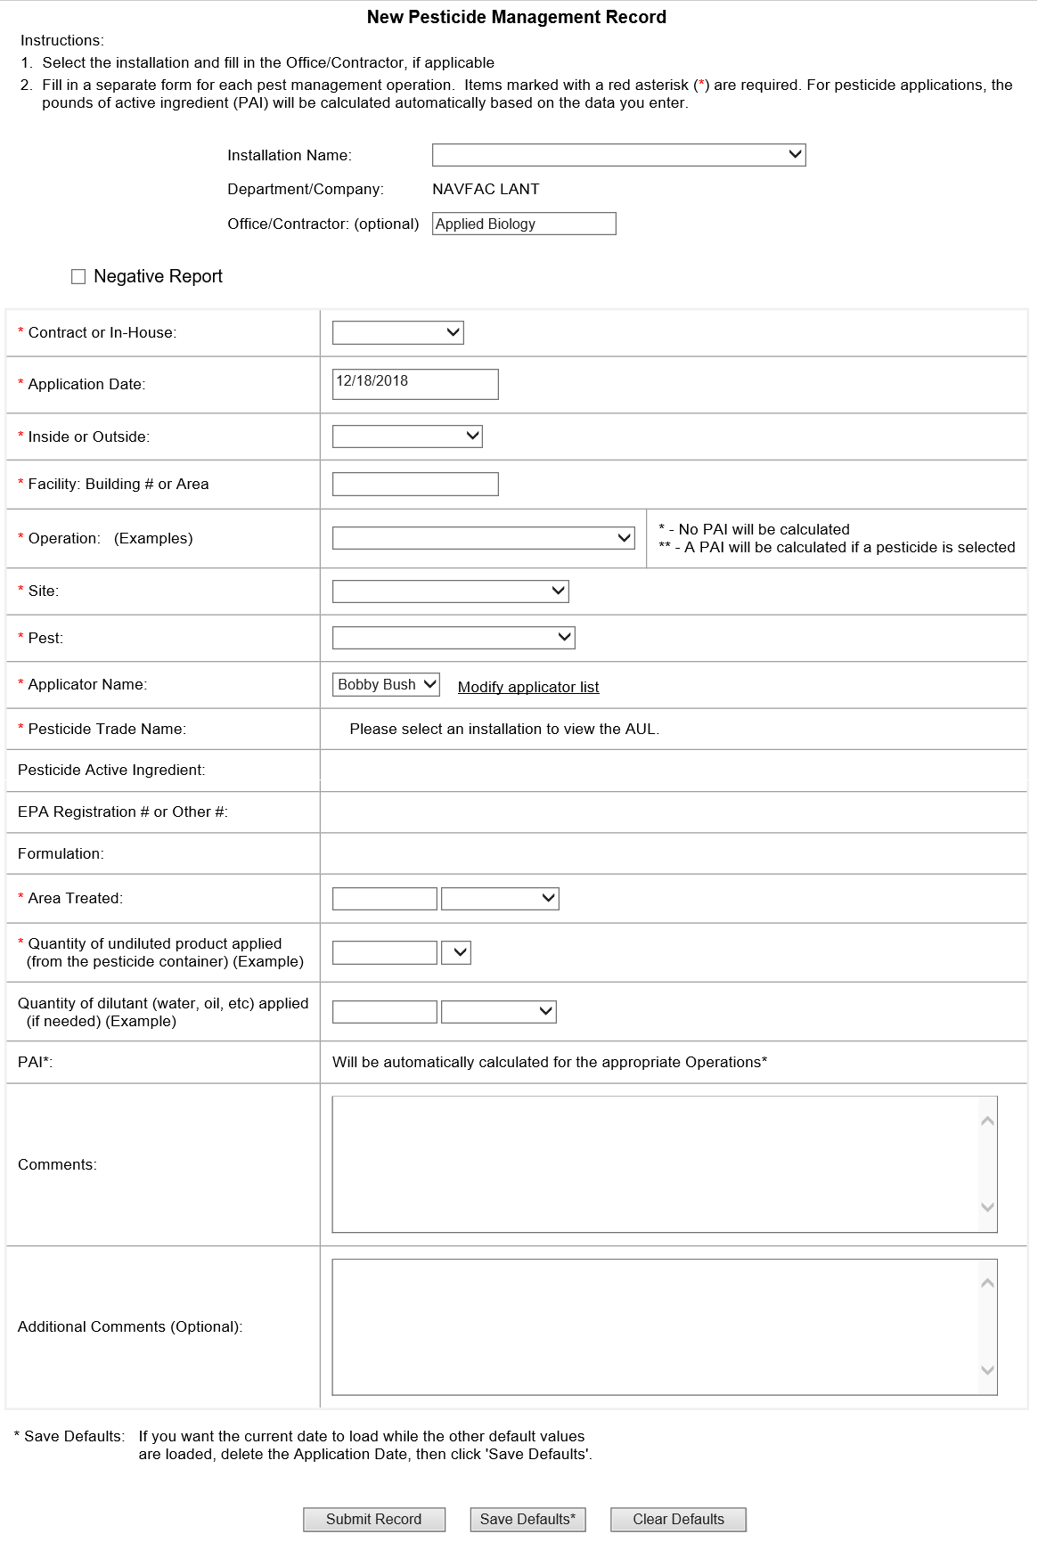

ATTACHMENT J-1503020-1 6

HISTORICAL IDIQ WORK

Description Location Size (sq. ft.) Date

Pest Control – Termite C-60 8,642 June 2020
Treatment

ATTACHMENT J-1503020-17
ADMINISTRATION AREA

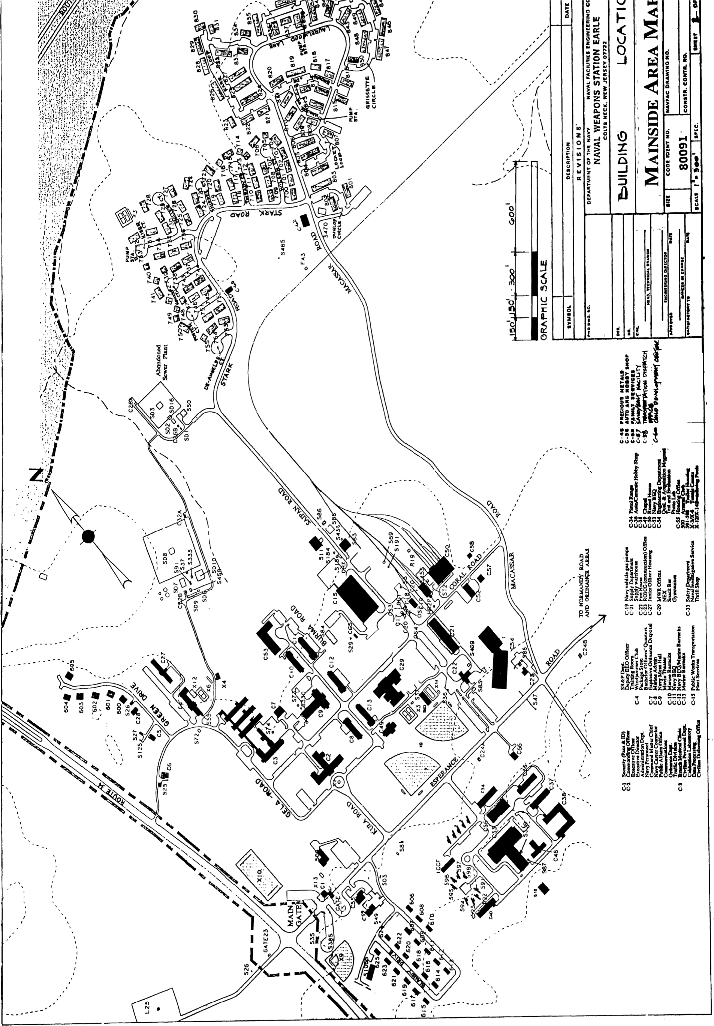

ATTACHMENT J-1503020-18 ORDNANCE AREAS

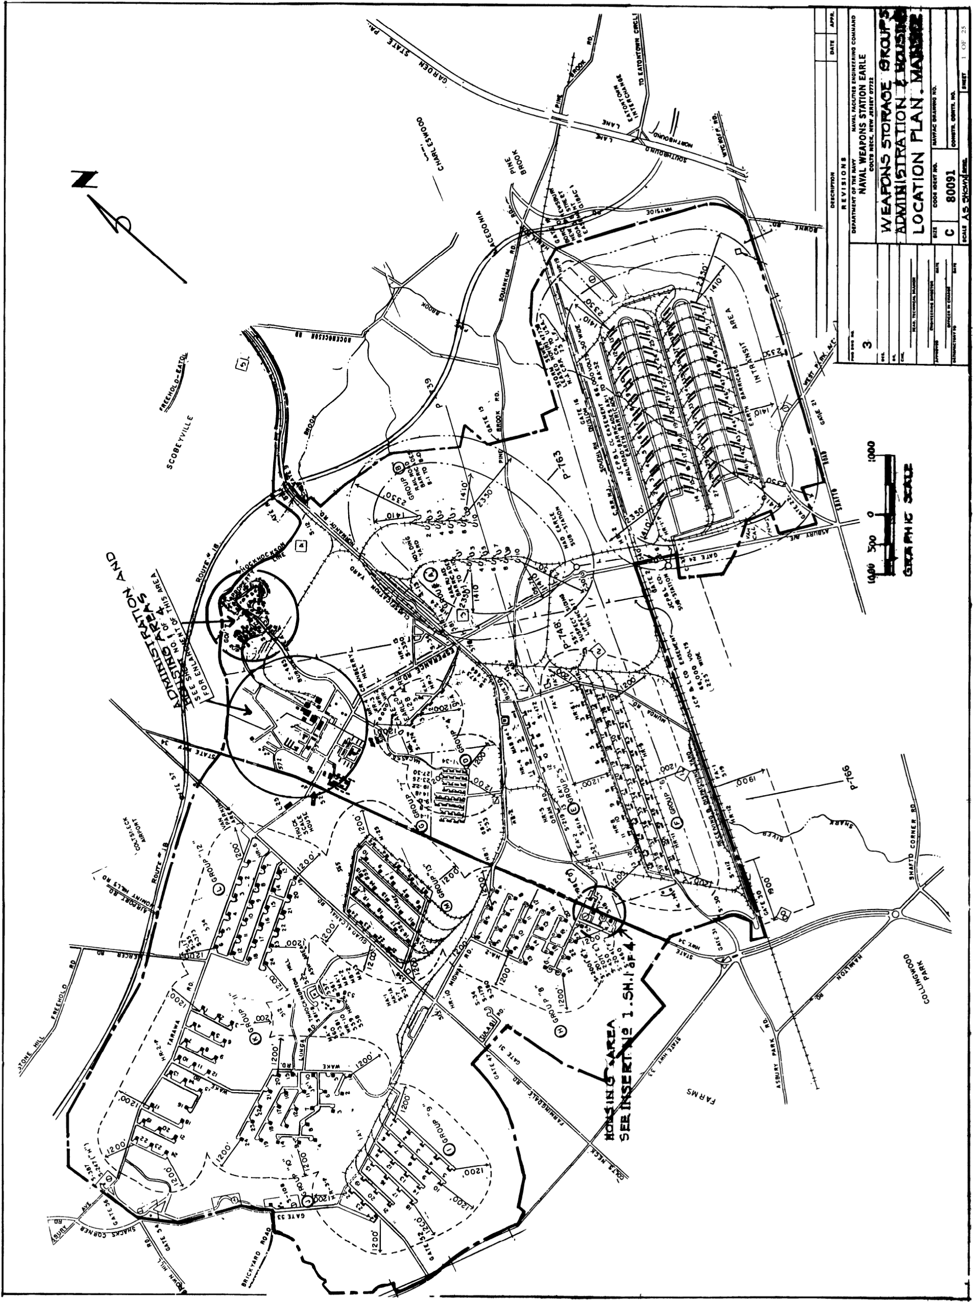

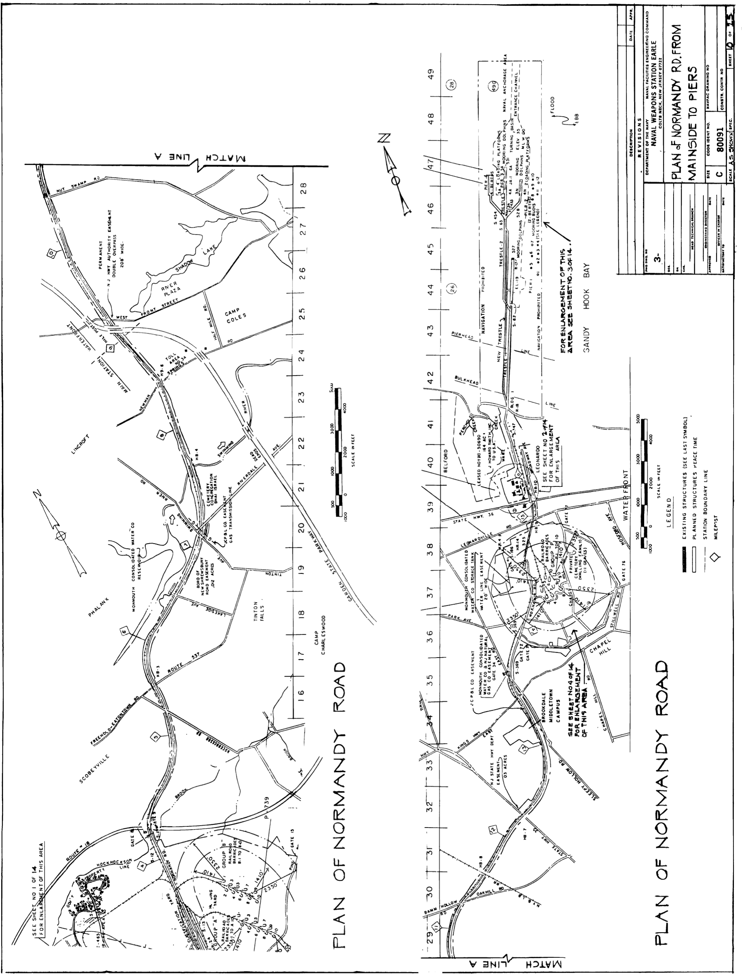

ATTACHMENT J-1503020-18
WATERFRONT INLAND AREA

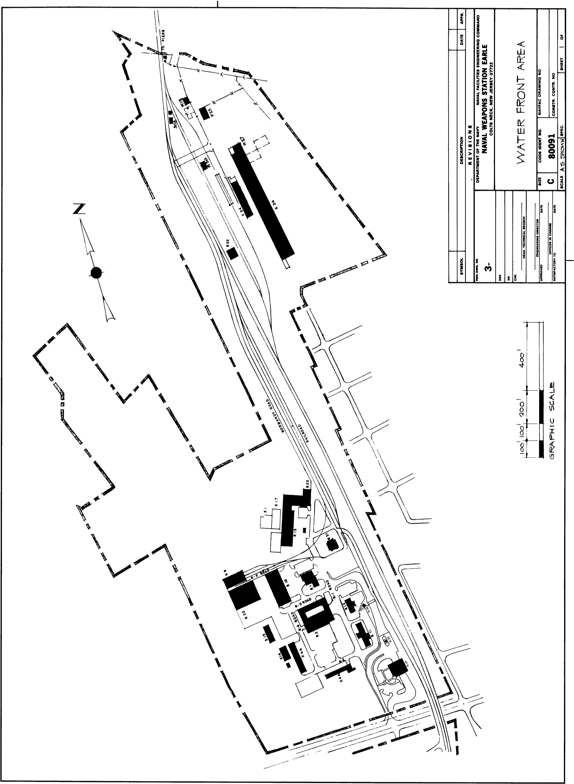
ATTACHMENT J-1503020-18
WATERFRONT INLAND AREA

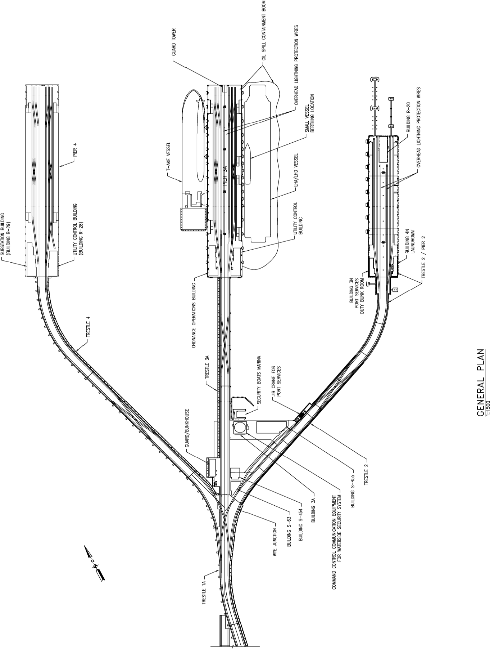

ATTACHMENT J-1503020-18

FACILITIES REQUIRING TERMITE INSPECTIONS – COLTS NECK
BLDG. NO. | DEPT | AREA  (SF) | USE | LOCATION
500 | BASE COMMAND | 5,994 SF | EOD | ESPERANCE ROAD
534 | GENERAL WAREHOUSE  (RI) | 800 SF | ORDNANCE CARPENTER SHOP | TARAWA ROAD
550 | FLEET (SELF HELP) | 4,200 SF | OLD STABLE | SEWER  PLANT AREA
583 | MORALE, WELFARE, RECREATION | 4,000 SF | PAVILION | BLDG. C-29
C-1 | SECURITY | 2,507 SF | SECURITY OFFICE | FRONT GATE
C-2 | COMMAND | 19,192 SF | BASE COMMAND | KULA ROAD
C-3 | COMMAND | 38,694 SF | RESERVE RECRUITING  COMMAND | GELA ROAD
C-4 | MORALE, WELFARE, RECREATION | 11,540 SF | CLUB | GELA ROAD
C-7 | RESERVE CENTER | 3,134 SF | RESERVE CENTER (KEARNEY) | RD. C-3  ADMIN.  AREA
C-8 | TENANT (NAV. LEGAL) | 4,800 SF | OFFICE | BURMA ROAD
C-9 | PUBLIC WORKS | 20,459 SF | OFFICE | BURMA ROAD
C-10 | MORALE, WELFARE, RECREATION | 15,172 SF | ENLISTED BARRACKS | BURMA ROAD
C-11 | MORALE, WELFARE, RECREATION | 15,172 SF | ENLISTED BARRACKS | BURMA ROAD
C-12 | MORALE, WELFARE, RECREATION | 15,172 SF | ENLISTED BARRACKS | BURMA ROAD
C-13 | MWR | 15,172 SF | ENLISTED BARRACKS | BURMA ROAD
C-15 | PUBLIC WORKS | 47,385 SF | PUBLIC WORKS SHOPS | SAIPAN ROAD
C-21 | NMCI | 18,147 SF | OLD SUPPLY WAREHOUSE | SAIPAN ROAD
C-22 | SAFETY | 8,095 SF | FIREHOUSE | SAIPAN ROAD
C-27 | MORALE, WELFARE, RECREATION | 102,284 SF | QUARTERS | RD C-8
C-29 | MORALE, WELFARE,  RECREATION & NAVY EXCHANGE | 26,639 SF | STORE | CORAL ROAD
C-33 | MILITARY SEA LIFT  COMMAND, ORDNANCE, | 45,547 SF | STORAGE/TRAINING AREA | ROAD T-3
C-34 | SECURITY | 14,342 SF | SMALL ARMS RANGE | ROAD T-1
C-36 | MILITARY SEA LIFT COMMAND | 14,432 SF | TOP FLOOR (VACANT) | ROAD T-2
C-37 | MILITARY SEA LIFT COMMAND | 14,562 | STORAGE (FIRST FLOOR) | ROAD T-4
C-38 | TENANTS | 16,562 SF | MARINE CORP RECRUITING | ROAD T-4
C-46 | MILITARY SEA LIFT COMMAND | 6,216 SF | OFFICE | ROAD T-5

ATTACHMENT J-1503020-18
FACILITIES REQUIRING TERMITE INSPECTIONS – COLTS NECK
BLDG. NO. | DEPT | AREA  (SF) | USE | LOCATION
C-49 | CHAPEL | 7,563 SF | CHAPEL & RELIGIOUS EDUCATION | BURMA ROAD
C-50 | PUBLIC WORKS | 19,422 SF | RAILROAD EQUIP. SHOP | E OF SAIPAN ROAD
C-51 | SECURITY | 54 SF | GATE/SENTRY HOUSE | MAIN GATE
C-52 | PHS&T | 4,100 SF | PHS&T STORAGE | E OF C-21
C-53 | MORALE, WELFARE, RECREATION | 10,730 SF | NAVY BARRACKS | BURMA ROAD
C-54 | FEMA | 39,950 SF | FEMA OFFICE CENTER | SAIPAN & ESPERANCE.
C-55 | PWD | 2,700 SF | HOUSING MANAGEMENT OFFICE | ESPERANCE ROAD
C-56 | MORALE, WELFARE, RECREATION | 12,000 | AUTO. HOBBY SHOP | ROAD T-1
C-58 | MORALE, WELFARE, RECREATION | 1,075 SF | MWR MAINTENANCE (&  Contractor) | CORAL ROAD
E-13 | ORDNANCE | 11,034 SF | AMMO. REWORK FACILITY | "E" AREA
E-14 | ORDNANCE | 11,322 SF | AMMO. REWORK FACILITY | "E" AREA
FA-1 | ORDNANCE | 320 SF | SMOKEHOUSE/LUNCHROOM | "E" AREA
FA-2 | ORDNANCE | 320 SF | SMOKEHOUSE/LUNCHROOM | "E" AREA
S-13A | PUBLIC WORKS | 2,508 SF | RR CONTROL ADMIN. | CLASS. YARD
S-17 | GENERAL WAREHOUSE  (RI) | 900 SF |  | TARAWA ROAD
S-35 | CARPENTER SHOP ORDNANCE AREA | 2,338 SF | ORDNANCE CARPENTER SHOP | TARAWA ROAD
S-349 | MILITARY SEA LIFT COMMAND | 6,000 SF | INERT STORAGE | W OF CLASS YARD
S-350 | MILITARY SEA LIFT COMMAND | 6,000 SF | INERT STORAGE | W OF CLASS YARD
S-472 | ORDNANCE | 262 SF | ORDNANCE FIELD HOUSE | "F" AREA

ATTACHMENT J-1503020-18
FACILITIES REQUIRING WOOD INFESTATION INSPECTI0NS (WATERFRONT)
BLDG. NO. | DEPT | AREA  (SF) | USE | LOCATION
514 | GENERAL WAREHOUSE  (RI) | 3,200 SF | (NWHC)
R-1 | FIRE STATION | 7,007 SF | ROAD R-1 | ROAD R-1
R-2 | SIMA (VACANT) | 26,970 SF | ROAD R-1 | ROAD R-1
R-4A | COMLOGRON | 15,200 SF | ROAD R-2 | ROAD R-2
R-4B | TENANTS | 15,362 SF | ROAD R-4 | ROAD R-4
R-5 | (WF) SECURITY OFFICE | 743 SF | ROAD R-1 | ROAD R-1
R-9 | SMALL BOAT SHOP | 8,546 SF | N OF TRANSIT SHED | N OF TRANSIT SHED
R-10 | PW SHOP | 14,271 SF | E OF TRANSIT SHED | E OF TRANSIT SHED
R-11 | BARRACKS (ENLISTED MEN'S) | 4,579 SF | ROAD R-1 | ROAD R-1
R-12 | NAVY EXCHANGE | 3,792 SF | ROAD R-1 | ROAD R-1
R-15 | GYMNASIUM | 19,095 SF | ROAD R-1 | ROAD R-1
S-357 | STORAGE (NWHC) | 234 SF | STORAGE | WEST OF BLDG. R-3

